**Disciplined Entrepreneurship Workbook**

# Step 15: Design a Business Model

**Worksheet:**

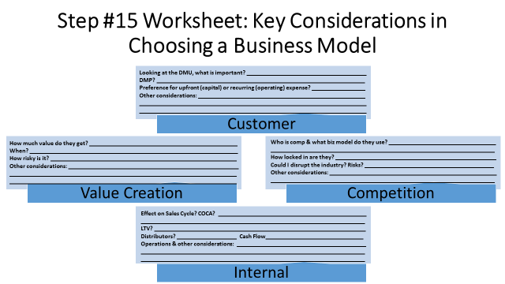

1. **Customer**

Looking at the DMU, what is important?

**Trust, ease of onboarding, transparent pricing, ability to self-serve.**

DMP (Decision-Making Process)?

**For solo travelers and students: emotional decision.**

**For corporate/retreat use: committee or budget approval.**

Preference for upfront (capital) or recurring (operating) expense?

**Solo travelers & students: low barrier, prefer freemium or pay-as-you-go.**

**Corporate: recurring with invoicing is acceptable.**

Other considerations:

**Simplicity, flexibility, and visible value early in the journey.**

1. **Value Creation**

How much value do they get?

**High: stress reduction, time saved, access to trusted local experiences.**

When?

**Immediate to short-term (1–3 days after signup).**

How risky is it?

**Low for freemium users. Subscription may feel risky unless value is proven upfront.**

Other considerations:

**Critical to onboard users with 1st “wow” moment within the first session.**

1. **Competition**

Who is comp & what biz model do they use?

**Airbnb Experiences (transactional), Nomad List (subscription), TripIt (freemium), Lonely Planet (book sales/digital content).**

How locked in are they?

**Moderately locked—platform trust and social proof matter.**

Could I disrupt the industry? Risks?

**Yes—by combining local expertise with social-driven recommendations.**

**Risk: Users default to “free search” options (Reddit, Google).**

Other considerations:

**Competitive edge lies in simplicity + authenticity.**

1. **Internal**

Effect on Sales Cycle? COCA?

**Low COCA due to influencer referrals and content marketing.**

**Freemium lowers sales friction.**

LTV?

**Moderate per user, can be increased via upsells and loyalty features.**

Distributors?

**App Stores, University travel clubs, Retreat organizers.**

Cash Flow:

**Subscription model is ideal for predictability.**

Operations & other considerations:

**Scalable with automation. Local guide vetting is the human bottleneck.**

**Identification of Different Units of Product You Can Charge For (if appropriate)**

What are the different potential units you could charge for? (e.g., individual product, number of users, usage, site license, etc.)

1. **Monthly Subscription:**

Pros: **Recurring revenue, predictable cash flow.**

Cons: **Harder to convert casual users; needs proven ongoing value.**

1. **Per-Trip Booking Fee**

Pros: **Low commitment, natural alignment with trip-based value.**

Cons: **Unpredictable revenue; lower per-user LTV.**

1. **Freemium and Premium Features**

Pros: **Low barrier to entry; upsell opportunity.**

Cons: **Value must be clearly demonstrated or users won’t upgrade.**

|  |  |  |  |  |  |  |  |  |  |
| --- | --- | --- | --- | --- | --- | --- | --- | --- | --- |
| **Summary of Business Model Candidates** | | | | | | | | | |
| **#** | **Option** | **Unit** | **Cust. Fit** | **Value Creation Fit** | **Comp.**  **Fit** | **Internal Fit** | **Pros** | **Cons** | **Grade** |
| 1 | **Freemium and Premium Subscription** | **Monthly sub** | **High** | **High** | **Medium** | **High** | **Scalable, flexible, low CAC** | **Risk of churn, needs strong onboarding** | **A** |
| 2 | **Pay-per-experience** | **Per trip** | **Medium** | **Medium** | **High** | **Medium** | **Aligns with casual travelers** | **Unpredictable cash flow** | **B+** |
| 3 | **Group Bundles** | **Group trip package** | **Medium** | **High** | **Medium** | **Low** | **Higher ticket value** | **Requires group planning infrastructure** | **B** |
| 4 | **B2B Licensing** | **Per organization** | **Low** | **Medium** | **Medium** | **Medium** | **Big contracts, higher LTV** | **Long sales cycles, onboarding barrier** | **C+** |
| 5 | **Ads**  **(for freemium only users)** | **CPM/CPA** | **High** | **Low** | **Low** | **High** | **Monetize free users** | **Low revenue per user, UX disruption** | **C** |

*Note: Do not forget to consider creative hybrid models if appropriate.*

1. **Initial Decision and Rationale**

Which business model did you choose and why?

**We choose Freemium and Premium Subscription Model. This model allows easy entry for casual or budget-conscious users while still enabling monetization through premium features such as offline access, personalized itineraries, and concierge services. It aligns with the lifestyle and decision behavior of solo travelers, students, and digital nomads. Low CAC and scalable infrastructure make it a strong internal fit.**

1. **Tests to Validate**
   1. What hypotheses are you assuming to be true for the business model(s) you have chosen?

**We believe that users will be willing to pay between €5 and €10 per month for access to personalized travel planning tools and exclusive content. Additionally, we hypothesize that the majority of perceived value is delivered within the first three days of usage, meaning a strong early experience is critical for conversion. We also expect that implementing a referral or loyalty program will increase user retention by at least 20%, as users will feel incentivized to stay and invite others.**

* 1. What experiments will you run to test your hypotheses?

**To test these hypotheses, we will run A/B pricing tests that present users with different value bundles at varying price points. We will track user behavior to monitor engagement, time to value realization, and freemium-to-premium upgrade rates. Additionally, we will run a two-week referral challenge that rewards users for inviting friends, and we will measure how many new users join as a result and how this affects retention.**

* 1. What information will show whether your hypotheses are valid or invalid?

**The hypotheses will be considered validated if at least 10% of freemium users convert to paid subscriptions, and if at least 60% of those paid users renew their subscription for a second month. Furthermore, if at least 15% of freemium users participate in the referral program by inviting at least one friend, we will see this as a strong indicator of viral potential and loyalty value.**

* 1. How long will you give the experiments to run?

**We will conduct these experiments over a four-week pilot period. During this time, we will continuously monitor key metrics and user feedback to evaluate performance and iterate quickly on what works best.**